Extracts from
2003 Botball Manual
©2003 KISS Institute for Practical Robotics

Robot Construction Rules
• Robots may be made out of any or all of the kit parts except: the
plastic box, bags and wrapping or packing material; the charger;
download cables and interface electronics
• Glue and tape may only be used for attaching non-Lego sensors,
servos and motors to the robot. Never glue Lego to Lego. No
glue or tape may be applied to paper!
• No more than one piece of LEGO may be glued to any of the
sensors. The servos & modified gear motor can have up to 7
pieces attached: one to each side and one to the effector plate.
Sensors that come from KIPR with one LEGO piece attached
may have one additional piece glued on, if desired

Robot Construction Rules (2)
• You may add 36 square inches of paper (max 20lb) or foil. The
paper/foil may only be held in place through the use of Lego and
other kit parts (no glue or tape). Paper may only be colored black
or white.
• You may add 36 inches of thread or line or cable (max diameter
1mm), for use ONLY as tensile elements in winches and pulleys
• Soda straws, paper, electrical tape and/or foil may be used as light
guides for the sensors (light guides may be attached by glue or
tape, but cannot be used structurally or for manipulation). Light
guide materials are in addition to the allowable parts.
• All robots must start themselves when the game light goes on.
Robots must stop themselves within 90 seconds after game start
• Robots must fit in starting box 15”L x 12”W x 12”H

Robot Construction Rules (3)
• Each robot kit contains two computers/power
sources
• If two robots are made from a single kit, they
represent a single tournament entry
• Two robots from a single kit must together fit
within the size constraints
• Two processors may exist on a single robot
• It is not necessary to use all the parts in a kit

Robot Construction Rules (4)
• No electrical modifications may be made to either
processor, any sensors or any motors
• No wire extensions may be used except those
provided in the kits (foil may not be used as wire!)
• No external communications may be used during
tournament play:
– No external IR transmitters may be used
– The serial cable and interface boxes may not be used during
tournament play
– Communications between a single team's robots is allowed

Robot Construction Rules (5)
• You may trim the connector potting material as needed to ease
insertion or mounting of sensors
• You may file or sand the mounting holes on the HB box to ease
mounting of Lego parts to the box
• You may use wire ties to neaten up the wiring on your robot
(cannot have any structural role)
• Servo accessories, grommets, screws, etc may only be used to
mount an effector plate (servo horn) to the servo, a piece of
Lego to the horn, or lego to the servo (one piece per face). Only
one servo horn may be used per servo.
• Servo horns may be trimmed to facilitate mounting to a Lego piece

Robot Construction Rules (6)
• Robot teams can have a maximum of 4
independent structures on the field
– All components together must fit in the starting
box without any external restraint
– Each piece must be large enough so that it does
not, in the judges opinion, constitute a jamming
hazard.
– Examples of structures include: robots, barricades,
detachable baskets, etc.

Robot Construction Rules (7)
• Lego parts cannot be physically modified
except for:
– Pneumatic tubing can be cut to desired lengths
– Lego straws and accordion tubes may be trimmed
to desired lengths
– Lego pieces being glued to a non-lego part may be
sanded or trimmed on the surface being glued to
ease attachment
• Each robot must have a name approved by an
adult team leader (G rated) before the
tournament

Game Board Setup
• The outside dimensions of the main field are 4' x 8'
• The inside dimensions of the gutter are 6" x 21.625"
(the centers of the 3 Ts are 11 5/16" apart and the
PVC is 1.5" in diameter)
• The bottom lip of the basket is 12" off the playing
surface (+/- 0.25")
• The far Ts of the two gutters are along the respective
foul line
• The foul lines are marked by 3/4" tape centered 12"
from the center line of the game board

Game Board Setup (2)
• The TP tubes are on the foul lines, one each in front
of the nests with foam balls
• The nests have an inside dimension of 4.75" and an
outside dimension of 7.75 "
• Each end of the game board is divided into 2 corner
zones separated by a starting box
• The corner zones and starting box are along a line that
runs the width of the field 15" from the inner edge of
the end of the field (i.e., occupying the strip 16.5" to
17.25" from the outer edge of the tile board) and
marked off by 3/4" tape

Game Board Setup (3)
• The starting box is a 12" x 15" rectangle centered
between the two corner zones and separated from
them by 3/4" tape
– the starting box is 12" W x 12" H x 15"L
• The starting boxes and corner zones are determined
by the inside edges of the tape and the PVC pipe
• The center line of the field is not marked.
• The official board will have pencil marks for the
corners of each nest and for each of the 6 TP tubes
• All measurements on official boards will be as
specified within +/- 1/4 inch. Deal with it.

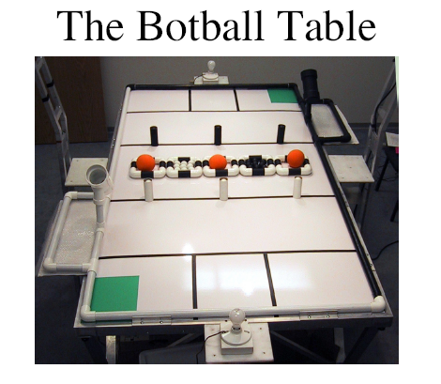

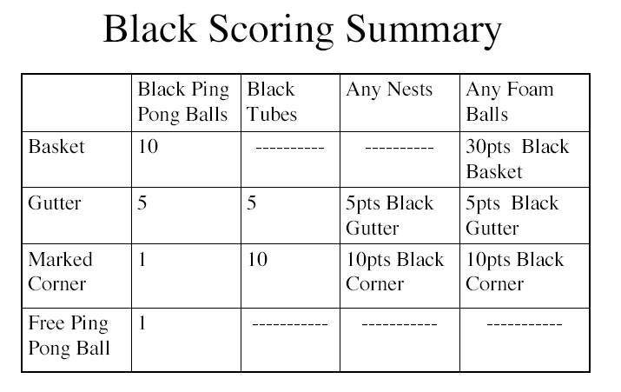

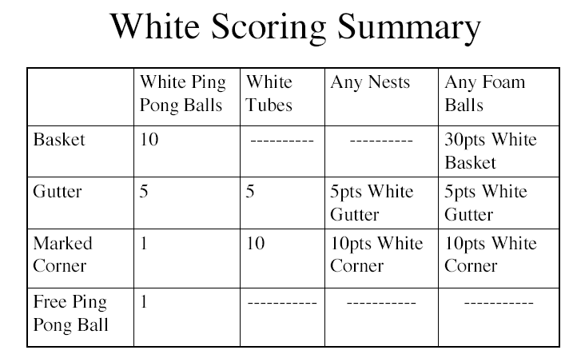

Game Rules & Scoring
• After "Hands-Off" and moments before the starting lights come on,
one of the corner zones on each side is marked with a colored piece
of paper becoming the marked corner zone.
• The marked corner zones are diagonally opposite
• The marked corner zone is defined at the game start. It does
not matter what happens to the marker during game play.
• Each team scores points by:
– freeing their balls from tubes and nests
– placing their balls in a gutter or basket
– getting the tubes, foam ball and nests in the marked corner zone or
gutter
– placing the team's balls in a basket
– placing the foam balls in the team’s basket

Scoring: Ping Pong Balls
A. Ping Pong Balls count for 1 pt:
– if their centers are within the vertical projection of the marked corner
zone, or
– if their centers are outside of the inner vertical projection of all nests
that are touching the playing surface and all upright tubes that are
touching the playing surface.
– if the enclosing tube is not upright (is more than 45 degrees from
vertical) or the enclosing nest is not touching the playing surface
B. Ping Pong Balls count for 5 pts if their centers are over the vertical
projection of the inside of the gutter.
C. Ping Pong Balls count for 10 pts if their centers are contained within
the volume of a basket.
D. Ping Pong Balls that satisfy requirements for more than one of A, B,
or C will be scored for the one category that gives the most points.
E. Ping Pong Balls score for the team whose color matches that of the
ball (the color of the gutter, etc is irrelevant for balls).

Scoring: Tubes
A. Tubes count for 5 pts if any part of them is over the
vertical projection of the inside of a gutter.
B. Tubes count for 10 pts if any part of them is over
the vertical projection of the inside of a marked
corner zone.
C. Tubes that satisfy requirements for more than one
of A or B will be scored for the one category that
gives the most points.
D. Tubes score for the team that matches the color of
the tube

Scoring: PVC Nests
A. Nests count for 5 pts if any part of them is over the
vertical projection of the inside of a gutter.
B. Nests count for 10 pts if any part of them is over the
vertical projection of the inside of a marked corner
zone.
C. Nests that satisfy requirements for more than one of
A or B will be scored for the one category that gives
the most points.
D. Nests score for the team that owns the gutter or
marked corner zone

Scoring: Foam Balls
A. Foam Balls count for 5 pts if any part of them is over the
vertical projection of the inside of a gutter.
B. Foam Balls count for 10 pts if any part of them is over the
vertical projection of the inside of a marked corner zone.
C. Foam Balls count for 30 pts if any part of the continuous ball
is contained within the volume described by the basket (this
includes balls touching the rim of the basket, but does not
include a part of the ball ripped off and placed in the basket).
D. Foam Balls that satisfy requirements for more than one of A,
B, or C will be scored for the one category that gives the
most points.
E. Foam Balls score for the team that owns the gutter or corner
zone

Tie Breaking
Tie breaking (in order):
1. Team with the most of their points in a basket
2. The teams with the most points in the marked
corner zones (not counting Ping Pong balls)
3. The team that has scored the most foam balls
4. The team with the most of their points in the
gutter
5. The team who has a robot with a power switch
closest to the support post for their basket.

Seeding/Performance Rounds
• S/P Rounds take place before the double elimination
• S/P rounds consist of best two out of three, unopposed
rounds.
• All teams play Black-ball side
• Scoring = (black score) - (white score)/2
• Scores of less than -1 will be counted as -1
• Passing on a round gives a score of -1 for that round
• Seed Score = average of best two rounds

Double Elimination
Tournament
• A team is out of the tournament when it has
lost two games
• Initial matches are decided by seeding round
using an "equitable draw"
• Matches are arranged using KIPR tournament
software
• Judges' decisions are final

Tournament Logistics
• No part of any adult is allowed over the vertical projection of
the outer edge of the pit area (with the exception of
tournament staff)
• Once teams register for the tournament, the role of teachers,
parents and mentors should be high-level coaching &
cheerleading.
• Robots may only leave the pit to go to the game tables
• Teams will know their side assignment (black or white) at
least 3 minutes before the match
• Up to 2 students from a team bring the robot to the
tournament table and set it up

Tournament Logistics (2)
• Teams shake hands and visually inspect each other's robots before
calibration.
• If either team wants to challenge the validity of the robots they are facing,
they have to do it then.
• Teams can bring the list of parts to the table to aid in the inspection.
• Inspection is limited to a max of 1 minute unless a specific challenge is
made.
• Challenges have to be of the form:
– That robot has too many X, or
– That robot has glue where glue is not allowed.
• Judges will be the final arbiter.
– Judges can dismiss what they believe to be spurious challenges
– Teams found in violation will (unless the judge decides there have been
extenuating circumstances) forfeit that round.
– In no case will a robot that is determined before the beginning of the round to
be in violation of the construction rules be allowed to play while in that state.

Tournament Logistics (3)
• Prior to the start of each round, a piece of colored 8.5" x 11" paper is
placed in each corner zone
• The starting lights (located directly behind the starting boxes) are on for
calibration, then turned off for final calibration
• When both teams are ready or judges decide adequate time has been
allowed for calibration, robots are activated and then -- Hands off!
• After Hands off, the judges will randomly remove either the left or
right piece of colored 8.5" x 11" paper from each team's corner zone.
The side (left or right) that still contains the paper will be the “marked”
corner-zone for that round. Note: the marked corner zone for each team
will be the same (both to the left or both to the right of their starting box)
• After Hands off, no part of a team’s robot(s) may leave the starting box
until the starting lights turn on
– If this happens, the judges will call a fault on the team
• If a team receives a 2nd fault in a round, they forfeit the round

Tournament Logistics (4)
• When the starting lights turn on the robots must autonomously start
• Lights will remain on for 5 seconds, turn off for 55 seconds and turn
back on for the final 30 seconds of the round, flashing the last 5
seconds
• No portion of a team's robot or structure may cross the opposing
team's foul line until one of the following has occurred:
– the opposing team's robot has crossed that foul line
– 5 seconds of the game have elapsed (the lights have turned off for
the first time)
• If a robot crosses the far foul-line early the judges will declare a fault
Remember: On a 2nd fault the team forfeits the round
• Once the starting lights have lit, the round counts unless a judge rules
outside interference.

Tournament Logistics (5)
• Robots may NOT send reprogramming commands before, during or after a
round.
• Teams cannot use infrared links to program their robots within 10 yards of the
game board
• Robots must cut power to their motors and turn off or stop issuing motion
commands to servos by the end of the round or the judges may zero their score
for that round (ties in this case are decided by the judge based on performance
during the round)
• Scoring is based on the location of pieces at the end of the round, not how the
pieces got there.
• Judges may at any time, while a robot is on the table, decide that a robot is in
violation of construction rules, and then disqualify that robot for that round.
Judges will not accept challenges to robots from the peanut gallery. Challenges
must come from the judges or the teams at the table.

Tournament Logistics (6)
• We don't care what LEGO, HBs etc there are in the pit.
Construction rules apply only to what is brought to the Game Table.
• There are no instant replays, we do not want to see videos of
questionable decisions. If a team is unhappy with a judge's
decision, they should challenge it then and there. Challenges to
scoring after the teams have left the table, will not be considered.
• Teams cannot touch, borrow equipment, modify robots or
computers, or beam commands to another team’s stuff (including
their pit table) without the permission and presence of a member of
that team
• The security of a team’s equipment is the responsibility of that team
-- don’t leave valuables unattended.

© 1997-2003 KIPR

