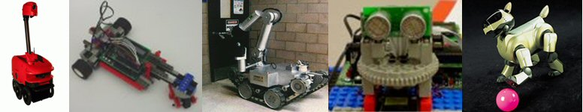
A Multidisciplinary Robotics Course Open to CS, ECE, IME, and ME Students
CS 490 Section 004 MW 3-4:15
ECE 492 Section 004 MW 3-4:15
IME 492 Section 001 MW 3-4:15
ME 492 Section 002 MW 3-4:15
A mobile robot is an integrated mechanical, electrical, and computational system that can function in the physical world. Unbound from the shackles of the stationary desktop, a mobile robot must include a variety of methods to navigate, perceive, and problem solve.
This course presents an integrated systems view of robotics with topics including vision, motion planning, mobile mechanisms, kinematics, and sensors. Students will construct sensors, actuators, and robots which are driven by a microcontroller. Each project will reinforce the principles discussed in lectures. Students will work in multidisciplinary teams consisting of an electrical/computer engineer, a mechanical engineer, a computer scientist and an industrial engineer. This course will also cover some contemporary happenings in robotics, which include current robot research, applications, and competitions.
Prerequisites
CS – Dr. Weinberg (Prerequisite CS 340 or consent of instructor)
ECE – Dr. Engel (Prerequisite ECE 327 or consent of instructor)
IME – Dr. Karacal (Prerequisite ECE 210 & ME 262 or consent of instructor)
ME – Dr. Karacal (Prerequisite ME 350 or consent of instructor)

Student teams will build robots using the Handy Board Microcontroller (www.handyboard.com). The Handy Board is programmed in Interactive C. Students will build and use a variety of sensors including the CMU color camera (http://www-2.cs.cmu.edu/~cmucam/).

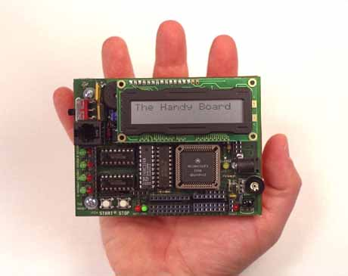 | 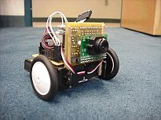
Course Website: http://roboti.cs.siue.edu/classes

